MOSQUITO Minimalist Transceiver
A QRPn transceiver with a MOSFET IRF510

Joan Morros, EA3FXF
Eduardo Alonso, EA3GHS
21/MARZO/2009, edited 9/mar/2012

Motivation
The main motivation of this new design is use a inexpensive high-power high-frequency MOS transistor like the IRF510 (DIGIKEY IRF510PBF-ND 1unit=1.12$ 10unit=0.7$). The typical bipolar power transistors like 2N3866, 2N3553,.. are hard to find or obsolete now. Very-high-frequency MOSFETs are in production by Mitsubishi. See RD series in RFPARTS.

circuit

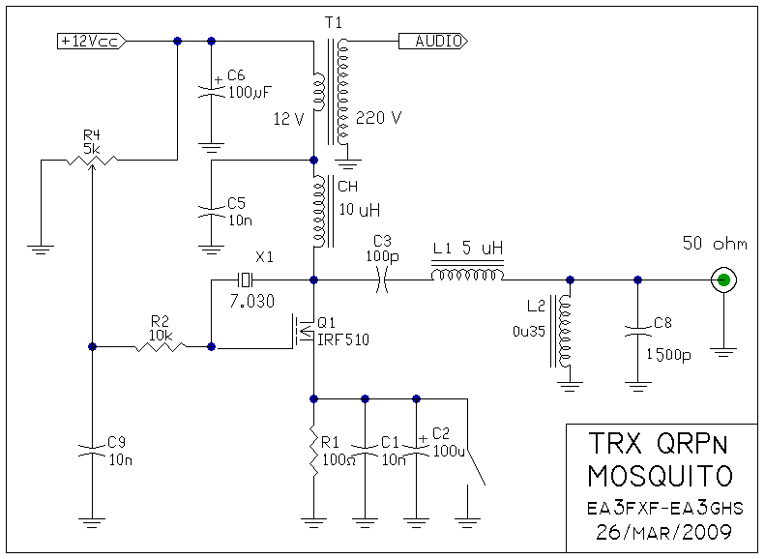
technical comments

Read/Write about this circuit in EMRFD group
Listen the technical description and a performance example in 40m band (in spanish)..
http://www.youtube.com/watch?v=lZo7wHhcR5Q

TX Bias
The transistor is supposed to work in class-A mode with a efficiency near to 50% (AC to DC power). A nice point to work is ID=200mA because the optimal load resistance to present to the transistor is 50 ohm. We do not need to use a output transformer, only a choke. The output power will be near 1'25W. To get more power, you need more drain current and mach the 50 ohm antenna to a lower impedance.
RX Bias
We put a 100ohm in the source to reduce the drain current to 30mA. Less current makes the oscillator unstable (metralleta effect: ta-ta-ta-ta). More current makes the unwanted radiation more powerful. This is currently under study.
RF Output Filter
Four simultaneously objectives must be meet:
- reduction of the 2nd and 3rd harmonic in TX mode
- 2 or 3 bands changing only the xtal: 80+40+30, or 40+30+20,..
- Reduce medium-wave broadcast signals. We can listen it by "direct-rectification", without mixing.
- low parts count

You can use the filters developed in SOFTROCK project:

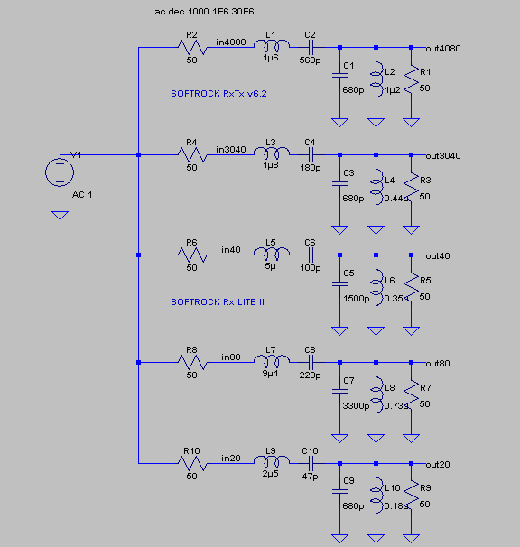
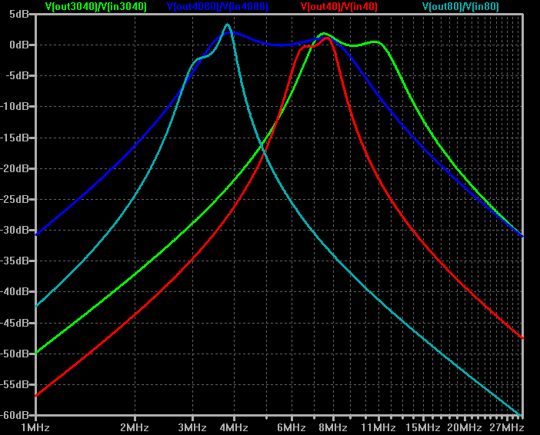

RX Sensibility
We are using a simple 12:220V 50/60Hz "printed circuit board" power supply transformer as audio transformer to adapt the high-impedance from the computer's sound card to a undefined low impedance. There are other solutions: a small XICON audio transformer, or a simple 47mH inductor in parallel with 4n7 capacitor. Interchanging the antenna and a 50ohm load, we can see the natural noise of the band. Then, no preamplifier is needed. Remember, a typical soundcard line input has more than +100dB dynamic range, with a full scale of 1Vrms/2.8Vpp (free).
Operation
For CW operation, toy need to answer to station near to xtal frequency (-3..+3 kHz). But you can listen stations between (-24..+24 kHz). Not to bad for a simple MOSFET.

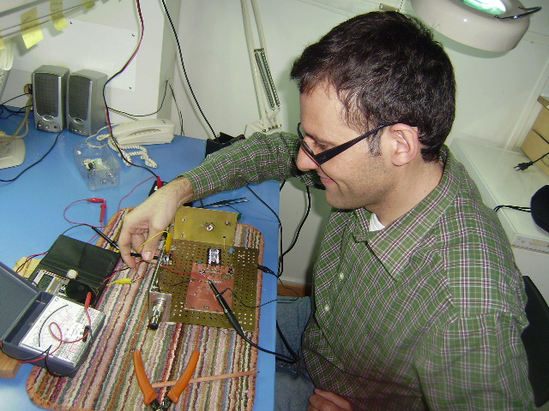
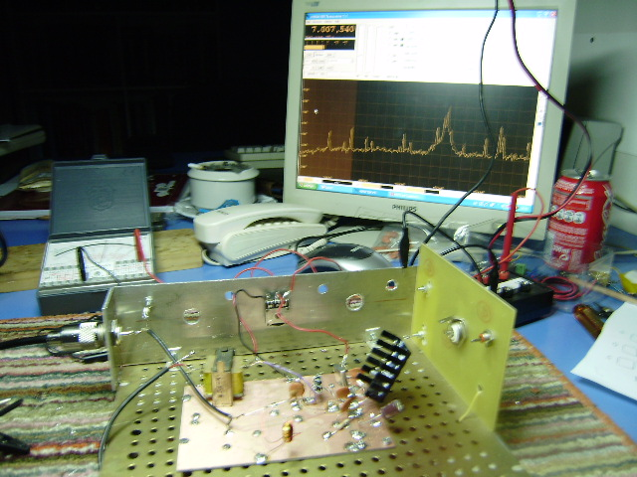
DSP
Here are the signal flow inside the computer:

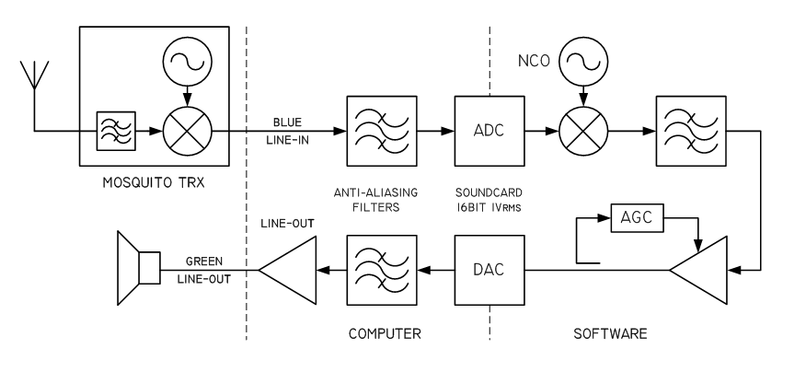

Thanks

Thanks to Jesus Bartolomé (radioastronomist), Manolo Santos (EA4BVZ) for all the comments and tests with the FLEA transceiver. Thanks to Stephen Wandling (VE7NSD) for to be the first to test our machines, and to Bill N2CQR (from SOLDERSMOKE bulletin) for his comments.



