VERY SIMPLE SOFTWARE-DEFINED DSB RADIO
by Eduardo Alonso, EA3GHS
http://ea3ghs.googlepages.com

It is a technique very used in millimeter-wave-band when the active elements are difficult to build and therefore expensive. The idea is to use a simple diode like mixer. It seemed good idea to me to apply this circuit in the populated band of 40m.

Figure 1

The sum of the local oscillator voltage and the antenna voltage VRF+VLO it is applied to the diode. In a diode, the current varies exponentially to the voltage, appearing currents that they are of double frequency of the oscillator 2*FLO, of the antenna 2*FRF, as well as the frequencies sum FLO+FRF and difference FLO-FRF.

We extract the difference current FRF-FLO by means of a resonant LC network. For the rest of signals, this filter appears like a short circuit. Do not confuse this circuit with a crystal radio.

This circuit has a disadvantage: the signal of the oscillator has an easy way towards the antenna and it radiates. Nevertheless, it is very didactic and it reduces to the minimum the pieces necessary to construct a receiver.

This receiver follows the minimalist philosophy and it has not a postmixer amplifying stage. In my case, the noise coming from the antenna is inferior to the generated by the quantization of the signal. This can be observed easily: the level of noise observed in the s-meter does not change when the receiver is switched off. Use the microphone input of your soundcard.

During the morning of the EA PSK31 TEST I could listen 14 different stations with a simple dipole antenna, some with signals of almost +30dB of S/N.

An adjustable resistance has been placed because there is a point of maximum gain. This approximately corresponds to 0.45VDC in the diode and amplitude of the oscillator of 200mVpp.

One open question to the reader: what kind of signals appears in the antenna side if we connect the receiver to the soundcard output?

MIX
DBL
ADC
MIX
SSB
OSC
DAC
BPF
BPF
AGC
BPF
BPF
DEMOD
PSK31
HARDWARE
SOFTWARE

OSC

Figure 2: the signal path over hardware and software blocks
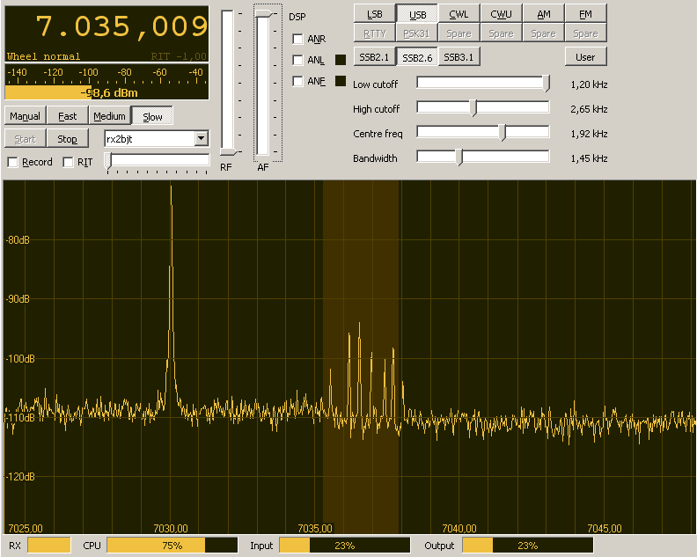
Figure 3: The M0KGK’s program shows seven nice PSK31 signals near 7036 kHz. Use WINPSK to decode them.

