TRIPPI15, DSB detector for software-defined radio
by Eduardo Alonso, EA3GHS
ea3ghs @ qrp.cat http://ea3ghs.googlepages.com

My interest in shortwave communications has been centered in digital modes. Here we discuss a small crystal controlled double-sideband receiver with digital intermediate frequency, covering from 21066 to 21114 kHz.

This circuit has been designed as simple as possible. Let’s see how works:

oscillator It is a Colppits oscillator running at 7030 kHz. This xtal is very easy to find in any QRP club. The output of oscillator is send to a multiplier.

multiplier A transistor working in on-off mode generates a current with a lot of harmonics. With a high-Q LC network we extract the third harmonic: 21090 kHz. We connect the multiplier to the 220 ohm mixer input port with a capacitive transformer. I measured 1’5Vpp here (+1dBm/220ohm).

mixer It is the receiver’s core. The signal from de local oscillator VLO is injected in the source of the FET. The signal from the antenna VRF is injected in the gate. The transistor generates a drenator current proportional to the difference squared, ID=k*(VLO-VRF)^2 appearing harmonics currents in FRF+FLO, 2FRF, 2FLO and, the most important for us, FRF-FLO.

IF filter The PSK31 traffic is centered in 21070 kHz. We extract de difference signal from the drenator current with a LC filter centered in the lower sideband 21090-21070=20 kHz. This signal is send to the computer (or to an audio amplifier). The bandwidth here is not very well defined. The sound card input impedance is not lower than 1 kohm. Attention, you will listen signals and noise simultaneusly at 21090+20=21110 kHz from the opposite sideband.

RF filter The preselector is a simple tuned circuit. At 21 MHz, I measured a Qu=70 in my 1.5uH inductor, ie an equivalent parallel resistance of RP=Qu*XL=70*2*pi*21M*1.5u=14 kohm. With a capacitive transformer, we adapt the 50ohm of the antenna to 14kohm of the LC filter. With SPICE, we estimated a medium-wave signals rejection of 70 dB. In on-air night tests I have not observed out-of-band signals (autorectification).This validate the balance between performance and simplicity.

digital IF Use the microphone input of the computer (max input level: 100mVpp). Digital signal processing can be made with a nice software from M0KGK. This program has a direct output to RTTY/PSK/... decoders like WinPSK and MULTIPSK. Try Canadian Rocky, too.

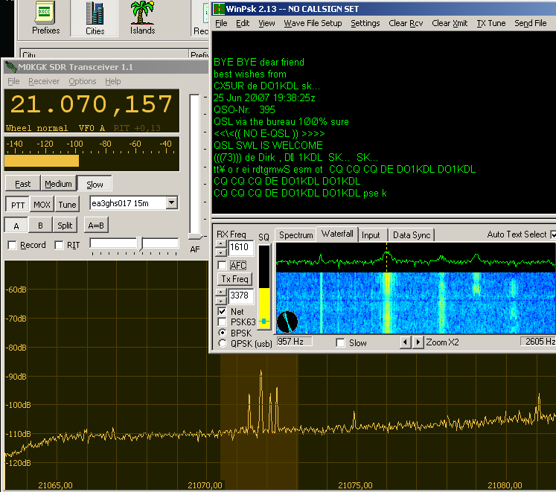

test 1 Connect the antenna to the receiver, read the noise floor level. Disconnect the antenna and read the noise level again.
If the level is the same (here is the same) the total receiver gain is not sufficient. The noise that you view in the screen is internal receiver noise, not atmospheric noise.

test 2 What antenna level I need to obtain 100 mVpp in the output (+0 dBFS/10kohm)?. in my case, I need 110mVpp (50ohm,-15dBm). The receiver has a power gain of -23dB. Fortunately, the sound card has a high input range and we can detect signals 100dB smaller: 1.5uV. Then, we can not hear signals under “S2”.

operation Few hours after I assembled this receiver, I was able to receive almost all central European countries. Unfortunately, we are in minimum solar cycle and the propagation is unstable. QSB can be viewed in PSK31 spectrograms. Few operators make fast contacts in PSK63 between propagation minimums (QSB). Some special stations were listened: PC650DAM from Holland, II2SFI “Spirit Flame of Italy” and TM7EO from France.

